Cloud Computing Practical

Assignment 1: Working on Google Drive to make Spreadsheets and Notes.

Working on Spreadsheets:

Step 1: Search Google sheets on the browser and click on the official link of the Google Workplace.

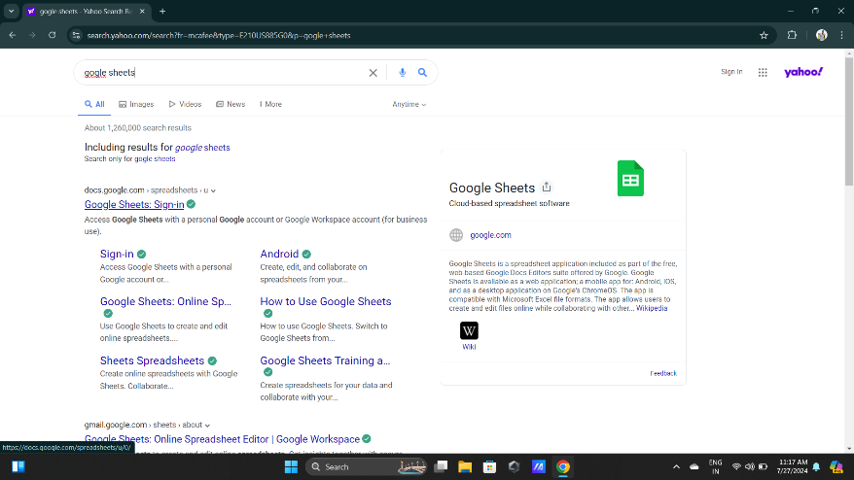

Step 2: Sign in to the Google sheets.

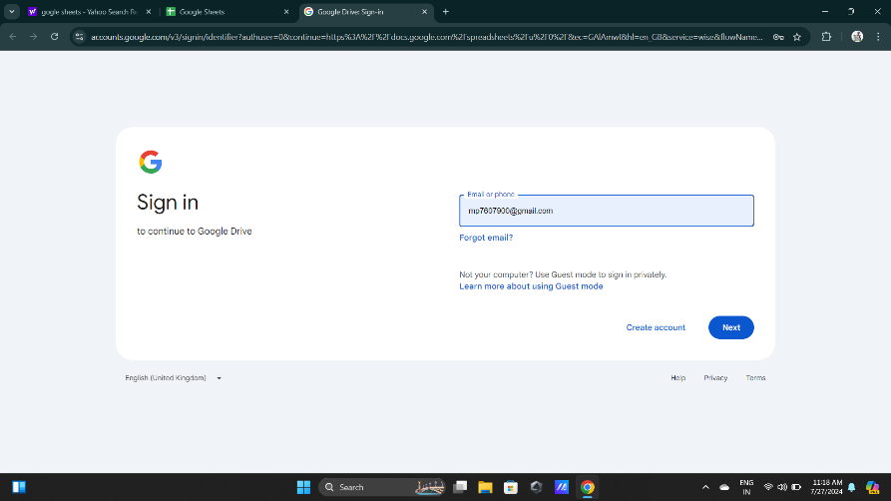

Step 3: Select blank document.

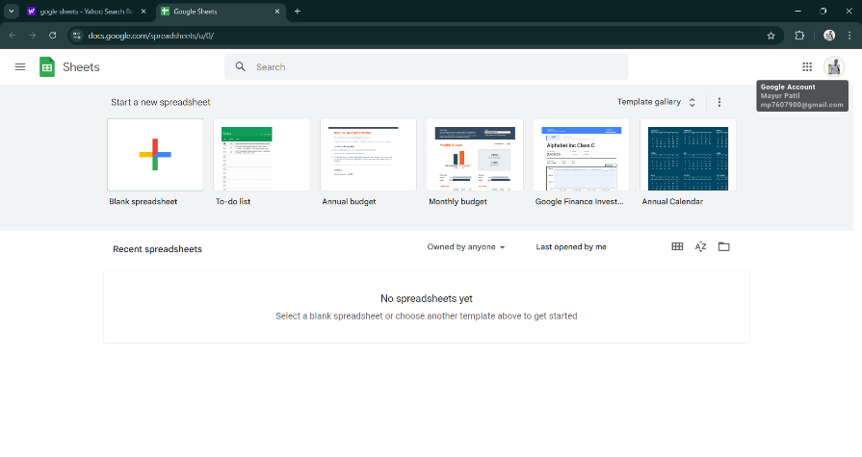

Step 4: Fill up the data into the sheets and save the name of spreadsheet, then click on the move button.

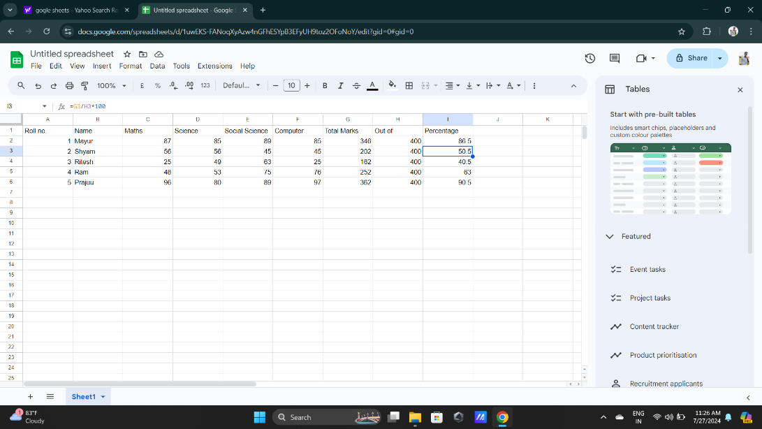

Step 5: Choose My drive and Select your desired location where you want to save your file, then click on the move button.

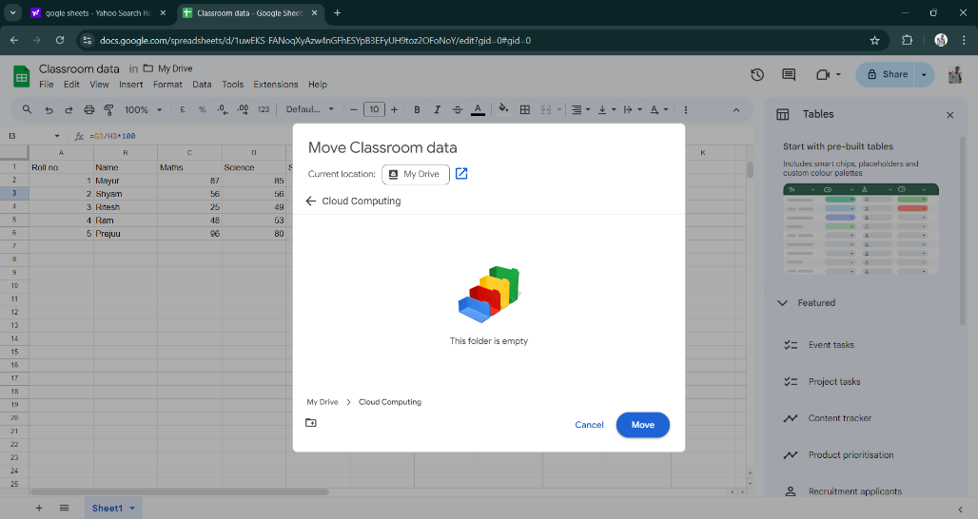

Working on Google Docs:

Step 1: Search Google docs on the browser and click on the official link of the Google.

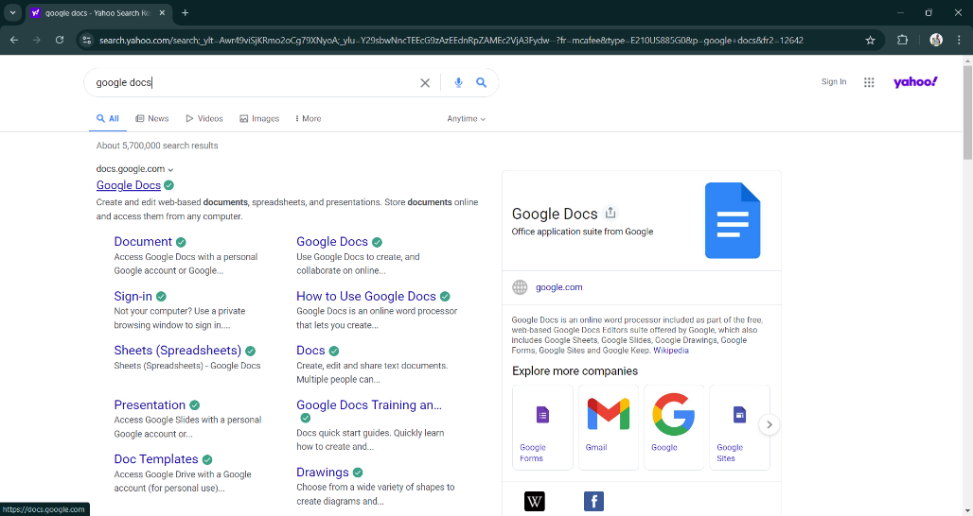

Step 2: Sign in to the Google docs.

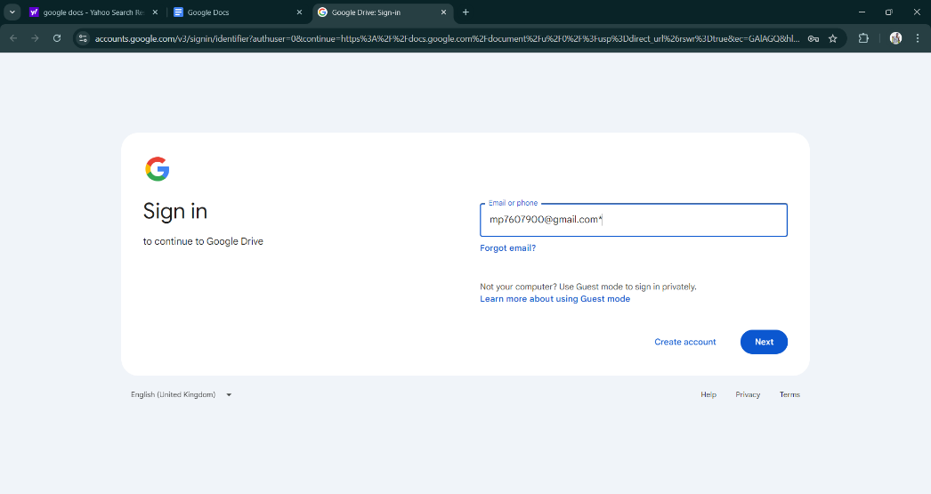

Step 3: Select blank document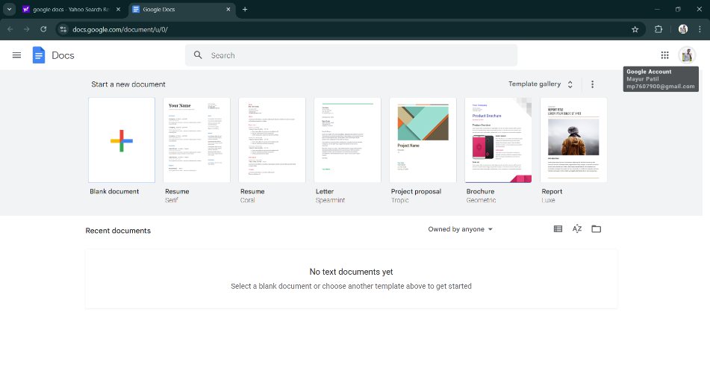

Step 4: Fill up the data into the document and save the name of document, then click on the move button.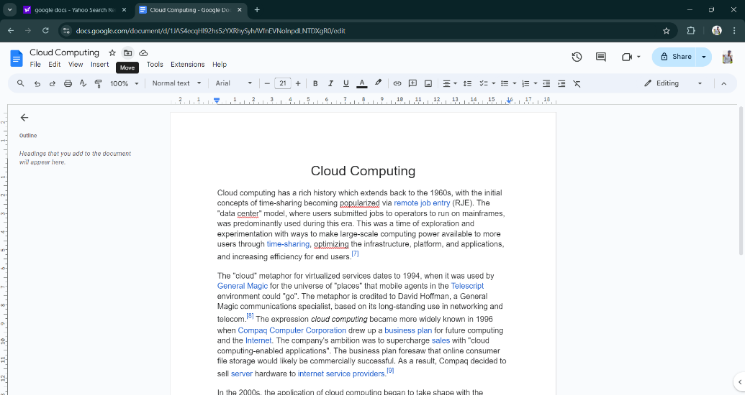

Step 5: Choose My drive and Select your desired location where you want to save your file, then click on the move button.

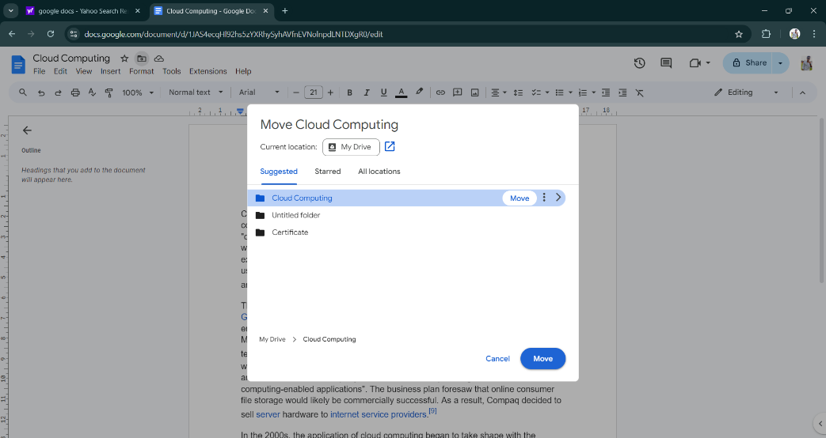

Assignment 3: Implementing Virtual machines with VirtualBox.

Installing VirtualBox:

Step 1: Search VirtualBox in your browser and click on the official link.

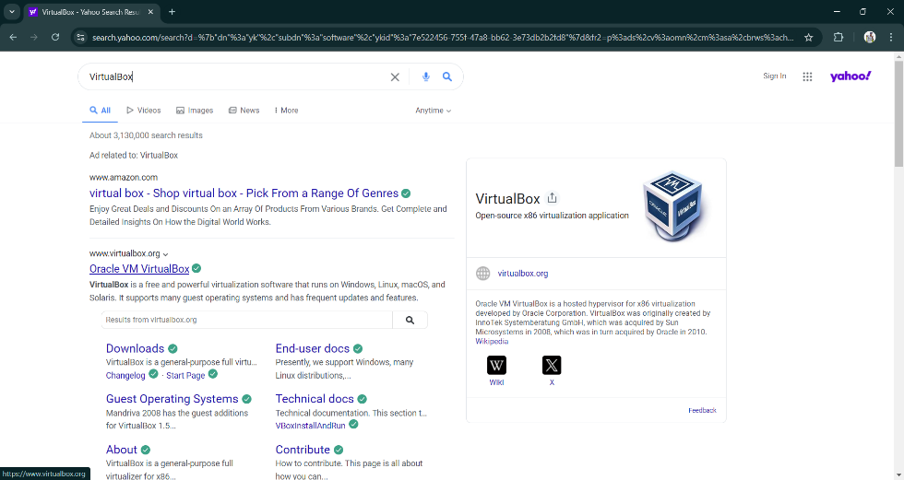

Step 2: Click on the Downloads.

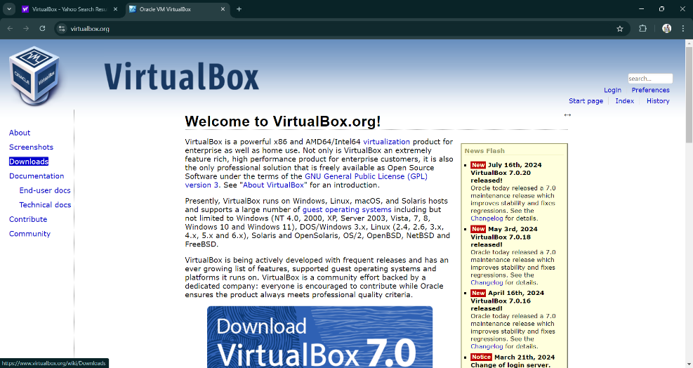

Step 3: Click on Windows Hosts.

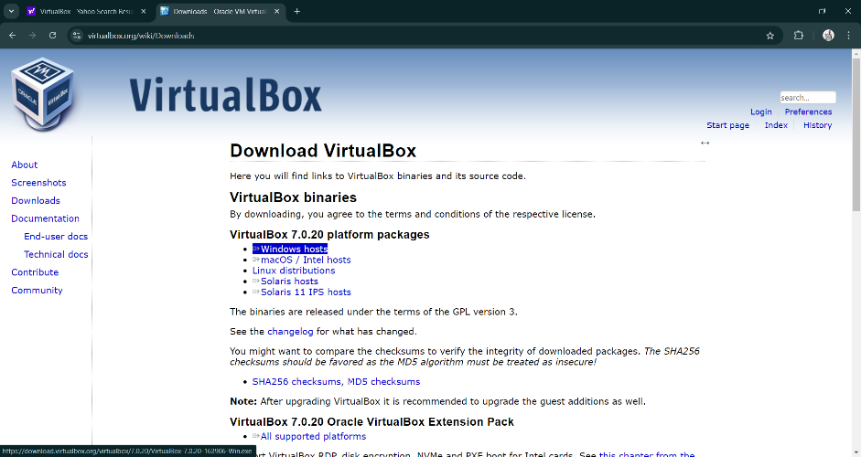

Step 4: Following dialog box will appear, Click on the next button.

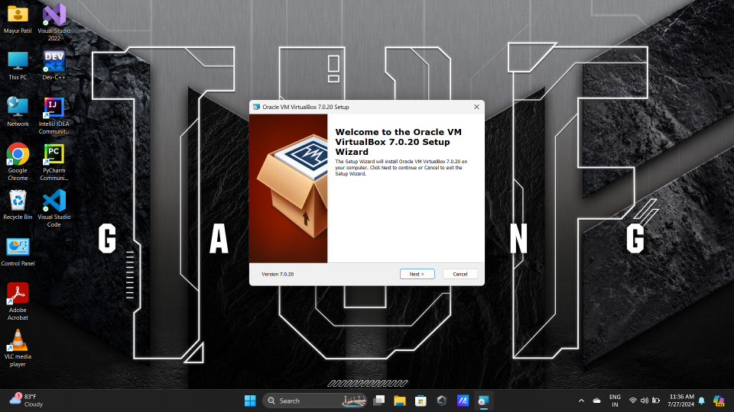

Step 5: Click on the install.

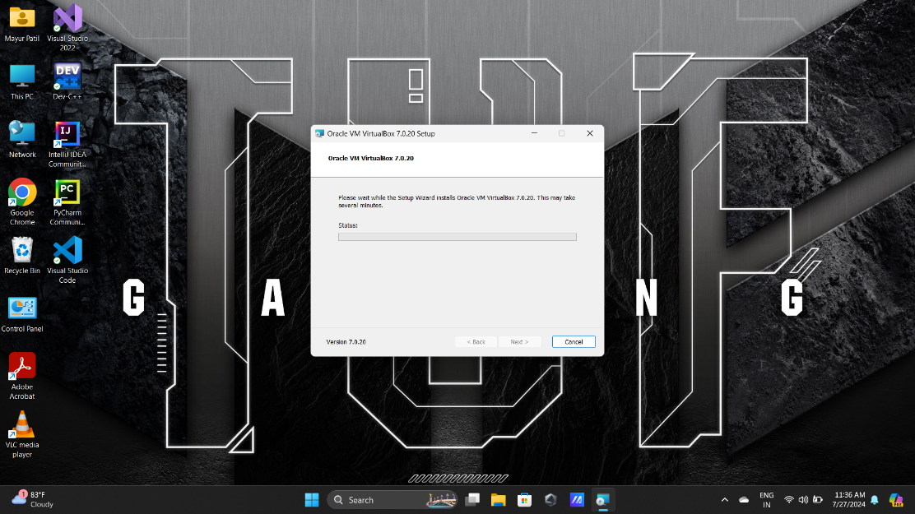

Step 6: After successful installing the VirtualBox, following screen will appear. Click on the new button. : Following dialog box will appear. Here enter your name and click on the Next button.

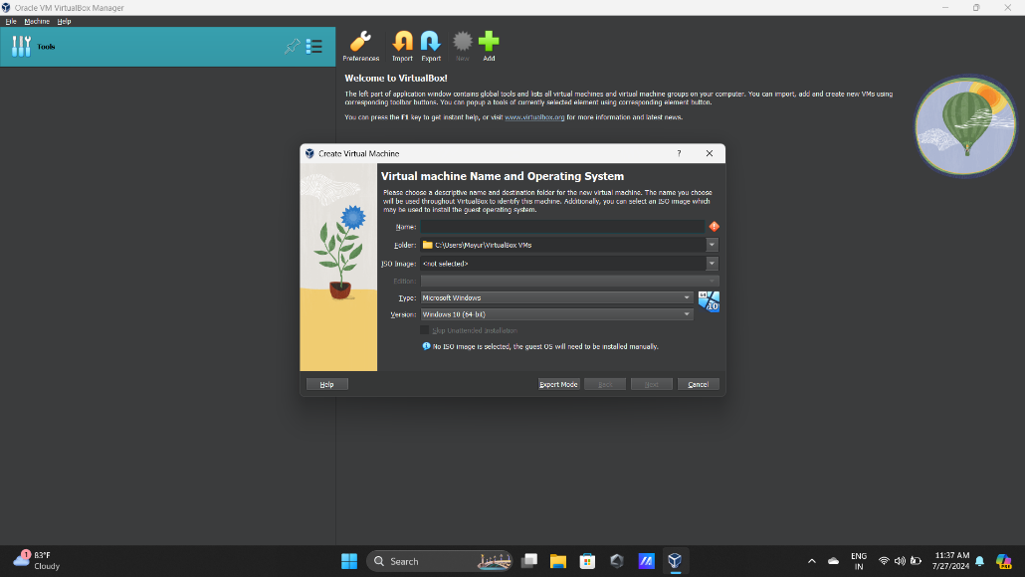

Step 7: Click on the next button.

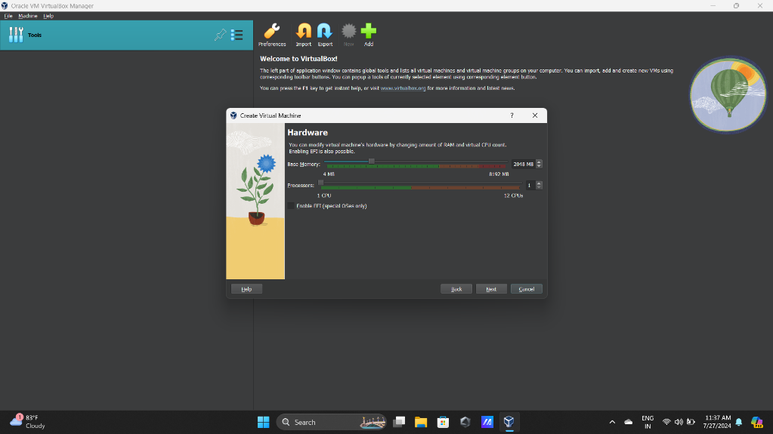

Step 8: Set the Storage amount and click on the Next button.

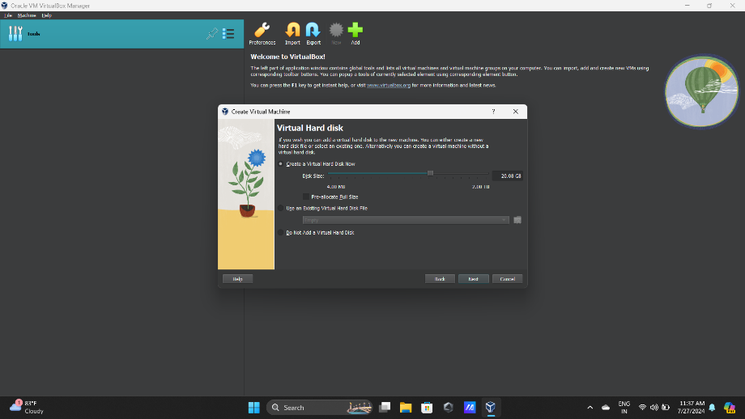

Step 9: At last, you will get the following screen where you will find the name of the Virtual Machine that we have recently created.

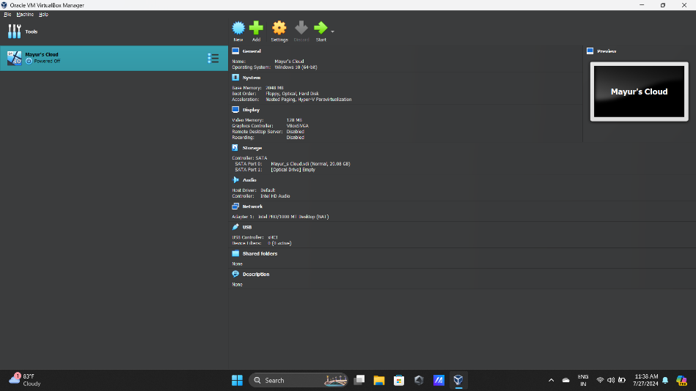

Installing ISO file for windows 10.

Step 1: Search ISO file for windows 10 in your browser and click on the official link.

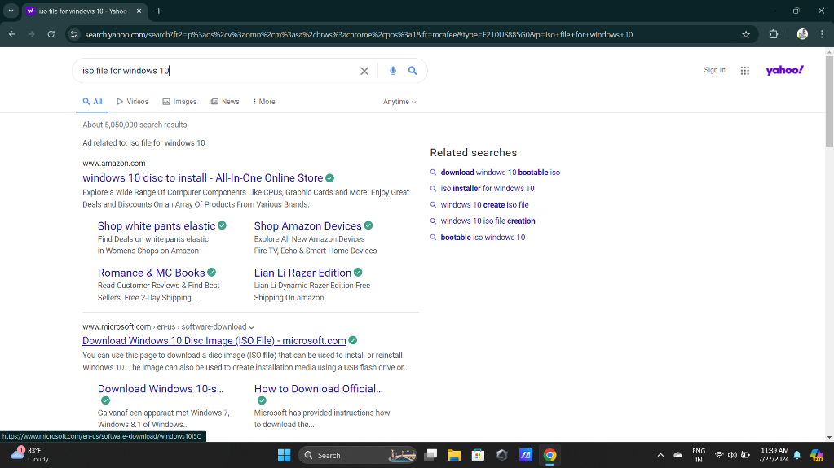

Step 2: Click on the download now button.

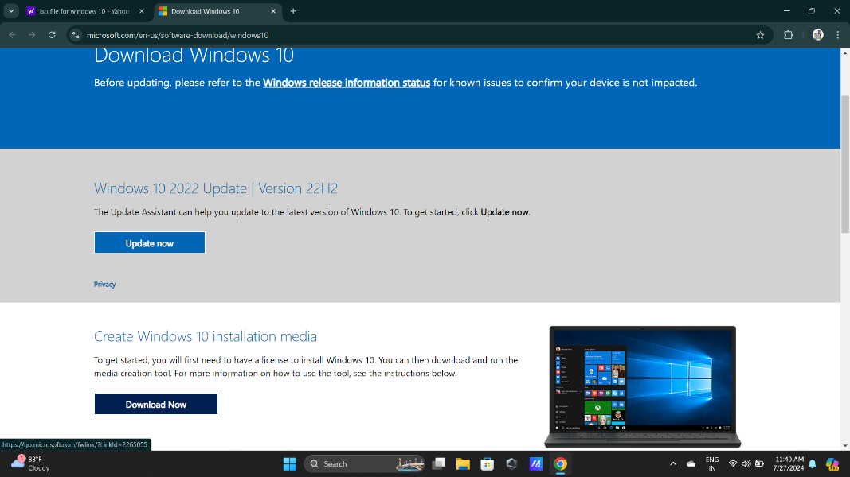

Step 3: After download gets complete, following dialog box will appear. Click on the Accept button.

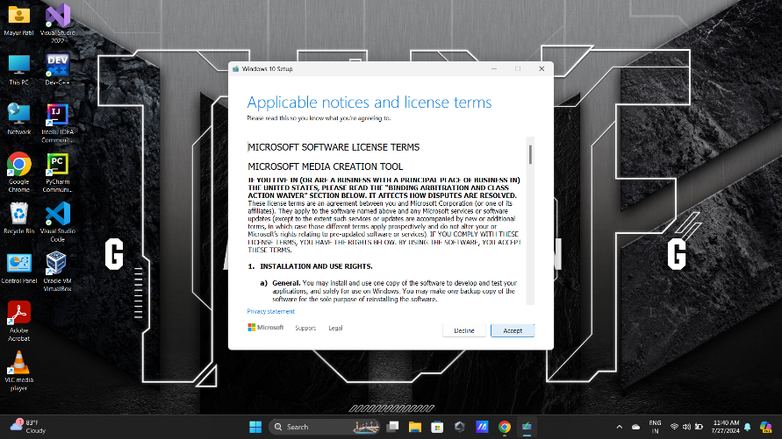

Step 4: Select the second option and click on the next button.

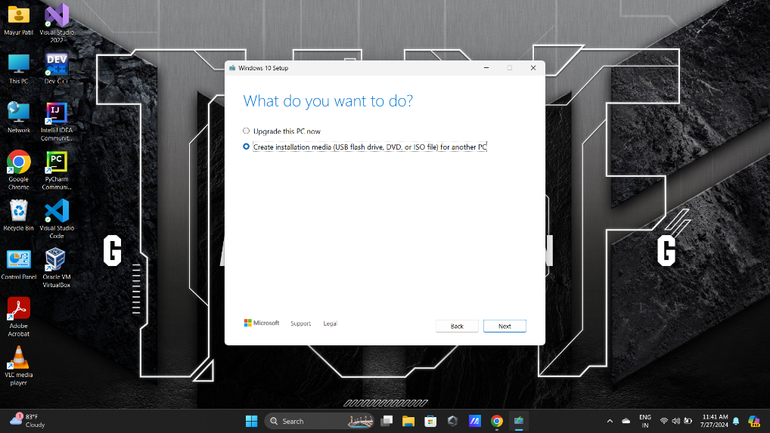

Step 5: Click on the Next button.

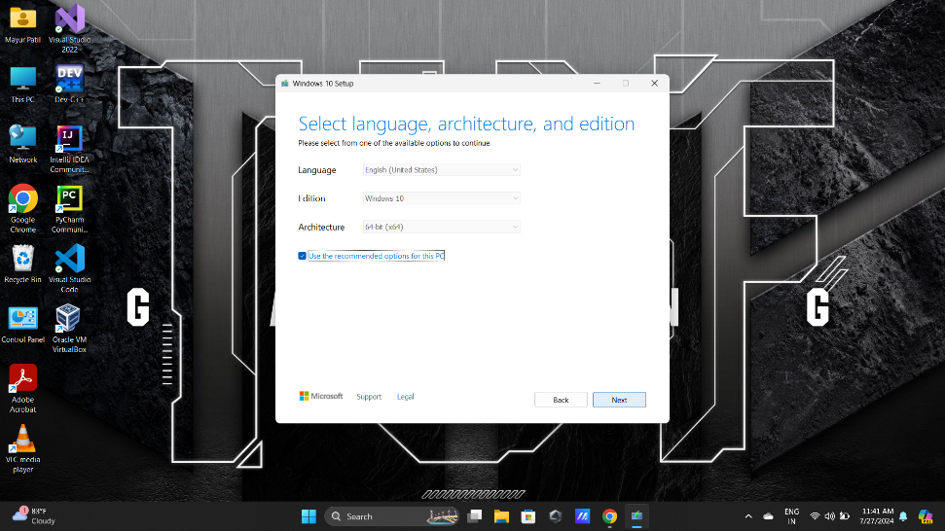

Step 6: Select ISO file and click on the next button.

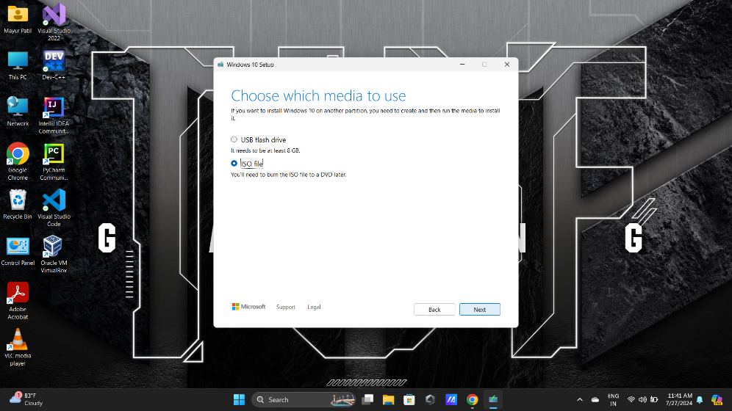

Step 7: Select the location where you want to save the file and click on the Save button.

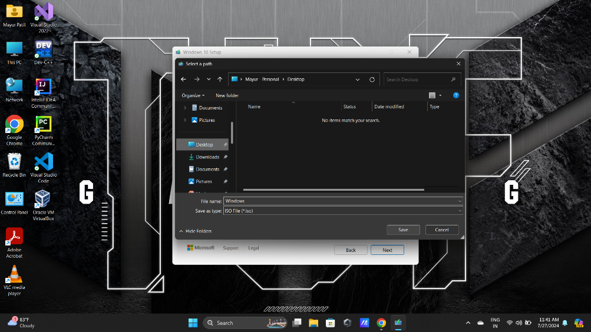

Step 8: After downloading gets complete, click on the next button.

